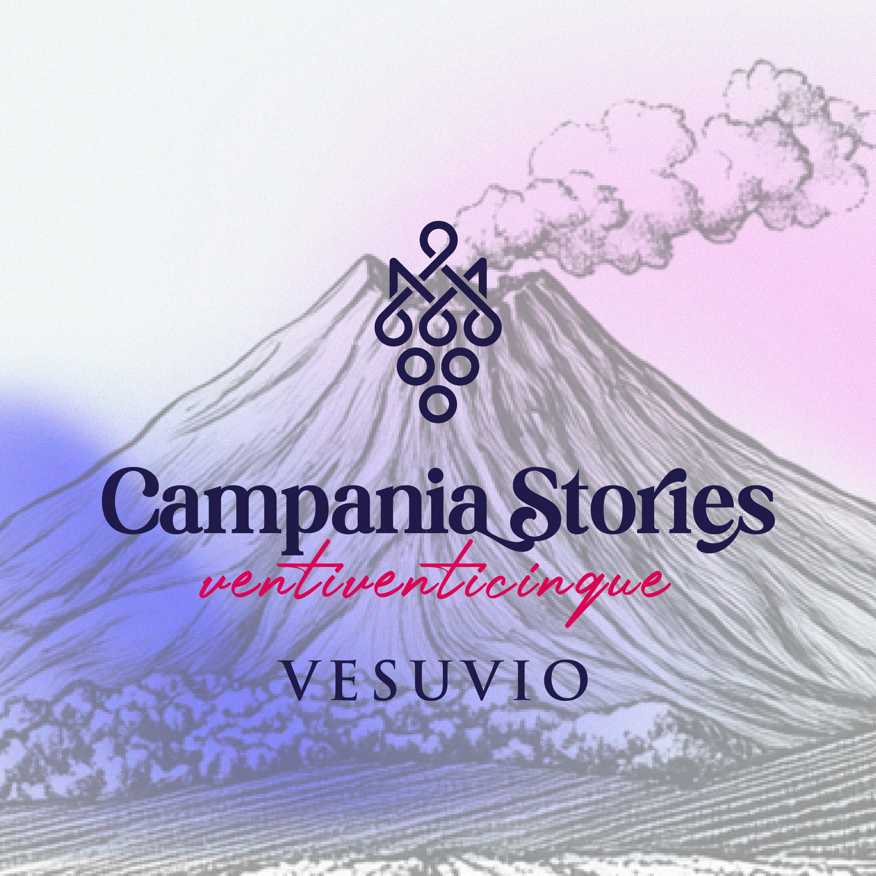
May 18–21, 2025 – Vesuvius (Naples)

VESUVIUS HOSTS THE 2025 EDITION OF “CAMPANIA STORIES”
NATIONAL AND INTERNATIONAL PRESS TO DISCOVER THE NEW VINTAGES
OF CAMPANIA WINES IN A LAND LIKE NO OTHER, RICH IN MYTH AND HISTORY

NAPLES – Vesuvius, a land like no other, steeped in myth and history, a cultural icon and an area with extraordinary volcanic pedoclimatic conditions, will host the 2025 edition of Campania Stories—the presentation of new vintages of wines from Campania’s main denominations to the national and international wine press, scheduled from May 18 to 21. Organized by Miriade & Partners with the support of the Campania Region and in collaboration with AIS Campania, the event will feature more than 90 wineries from across the region.

The 2025 edition will open on Sunday, May 18, with a guided tour of the Great Cone of Vesuvius and a press welcome at the historic Palazzo Mediceo in Ottaviano, hosted by the Consorzio Tutela Vini Vesuvio, which promotes and enhances one of Italy’s oldest and most fascinating winemaking traditions. Tastings will take place at the prestigious Villa Signorini in Ercolano, where national and international press will taste the new vintages of Campania wines. Dedicated tasting sessions are scheduled for rosé and red wines (May 19) and white wines (May 20), alongside guided tours of wineries and wine regions across Campania.
As per tradition, the event will conclude with the highly anticipated Campania Stories Day, scheduled for Wednesday, May 21—a day reserved for trade professionals and wine lovers at Villa Signorini (Ercolano) with three time slots(11:00–13:00, 16:00–18:00, and 19:00–21:00). Attendance requires advance booking and is subject to availability (for info: WhatsApp tel. +39 379.1371604 – eventi@miriadeweb.it).

Campania Stories is organized by Miriade & Partners in collaboration with AIS Campania, with the support of the Campania Region and co-financed under the PN FEAMPA 2021–2027 program.

Partners of the 2025 edition include: Consorzio Tutela Vini Vesuvio, Assoenologi Campania, Palazzo Mediceo (Ottaviano), Villa Signorini (Ercolano), Hotel Sakura (Torre del Greco), Viaggi Di Maio, Distretto della Castagna e del Marrone della Campania, Lunadimiele.it, Che Pasticcio, Azzurra Comunicazione.

Luciano Pignataro Wine Blog is the event's media partner.

Campania Stories continues to be a key event to promote the region’s wine excellence by organizing tastings for the international press, digital content initiatives, technical materials, and ongoing updates on the region’s wine production data—enhancing the image of Campania’s wine industry worldwide, 365 days a year.

Participating Wineries:
Irpinia (Avellino): Benito Ferrara, Borgodangelo, Cantina del Barone, Cantine dell'Angelo, Cantine di Marzo, Ciro Picariello, Colli di Lapio, Contrade di Taurasi - Cantine Lonardo, De' Gaeta, Di Meo, Di Prisco, Donnachiara, Giovanni Carlo Vesce, I Capitani, I Satoli, Il Cancelliere, Joaquin, Macchie Santa Maria, Masseria Della Porta, Passo delle Tortore, Perillo, Pietracupa, Rocca del Principe, Stefania Barbot, Tenuta Cavalier Pepe, Tenuta del Meriggio, Tenuta Pietrafusa by Villa Matilde Avallone, Tenuta Scuotto, Tenute Capaldo - Feudi di San Gregorio, Torricino, Traerte, Vesevo, Villa Raiano.
Sannio (Benevento): Aia dei Colombi, Cantina del Taburno, Cosimo Capasso, Fattoria La Rivolta, Fontanavecchia, La Fortezza, La Guardiense, Nifo Sarrapochiello, Terre Stregate.
Caserta: Alois, Cantina di Lisandro, Caputo 1890, La Masseria di Sessa, Masseria Felicia, Masseria Piccirillo, Porto di Mola, Scaramuzzo, Tenuta Fontana, Tenuta Tralice, Teresa Mincione, Villa Matilde Avallone, Vigne Chigi.
Salerno: Cantina dei Quinti, Cantina Polito, Ettore Sammarco, Guerritore, Luigi Maffini, Marisa Cuomo, Montevetrano, San Salvatore 19.88.
Napoli: Abbazia di Crapolla, Agnanum, Astroni, Bosco de' Medici, Cantina del Vesuvio Winery Russo Family since 1930, Cantine Antonio Mazzella, Cantine Olivella, Carputo Vini, Casa Setaro, Contrada Salandra, D'Ambra Vini d’Ischia, De Falco Vini, La Sibilla, Mario Portolano, Masseria Dello Sbirro, Radici Vive Mezanotte, Salvatore Martusciello, Sorrentino Vini, Tenuta Augustea, Tenuta Loffredo, Villa Dora.

More information at www.campaniastories.com

PRESS OFFICE
MIRIADE & PARTNERS SRL
Diana Cataldo – tel. 329.9606793
Serena Valeriani – tel. 392.0059528
Simone Argenio – tel. 333.5358744
E-mail: ufficiostampa@miriadeweb.it
Website: www.campaniastories.com

