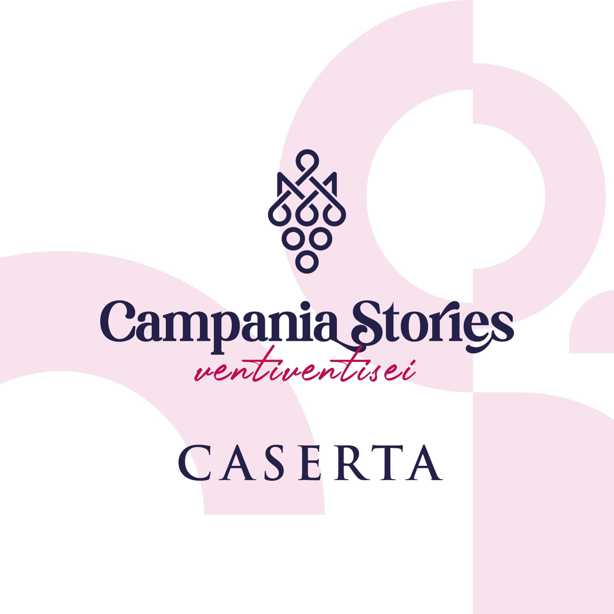
23-27 April 2026 – Caserta

FROM THE ROYAL PALACE OF CASERTA, THE 2026 EDITION OF “CAMPANIA STORIES”
NATIONAL AND INTERNATIONAL PRESS DISCOVER THE NEW VINTAGES OF CAMPANIA WINES
BETWEEN UNESCO HERITAGE, IDENTITY AND GREAT WINE TERRITORIES
CASERTA – The Royal Palace of Caserta, a UNESCO World Heritage site and a universal symbol of Campania’s historical and cultural heritage, will host the opening of the 2026 edition of Campania Stories, the annual presentation of new vintages from the region’s main appellations to national and international wine press, scheduled from April 23 to 27, 2026.
Organized by Miriade & Partners together with participating wineries, with the support of the Campania Region, in partnership with AIS Campania and in collaboration with the Consorzio Tutela Vini Caserta VITICA, the event will open on Thursday, April 23, with an inaugural day at the Royal Palace of Caserta, in a setting of extraordinary historical and artistic value, perfectly embodying the dialogue between culture, territory and wine.
Technical tastings will take place in the following days and will be organized by wine typology, offering national and international press an in-depth analysis of the new vintages of Campania wines, with sessions dedicated to white, rosé, red and sparkling wines, as well as further insights and visits across the region’s wine territories and wineries.
As tradition dictates, the event will conclude with the highly anticipated Campania Stories Day, scheduled for Monday, April 27 at the Vega Palace in Carinaro (Caserta), a day open to professionals and wine enthusiasts, with access by reservation and time slots (info eventi@miriadeweb.it).
The 2026 edition of Campania Stories is held with the support of the Campania Region, in partnership with AIS Campania and the Consorzio Tutela Vini Caserta VITICA, and in collaboration with the Royal Palace of Caserta, Assoenologi Campania, Marìcan, Vega Palace, Daman Ristorazione, APN – Associazione Pizzaioli Napoletani, Authentic Journey 54, Azzurra Comunicazione, Che Pasticcio, Distretto delle Castagne e dei Marroni della Campania, with media partnership by Luciano Pignataro Wine Blog.
Campania Stories confirms itself as a key event for promoting the region’s wine excellence, through tastings dedicated to international press, technical content, digital activities and in-depth experiences, helping to showcase and narrate Campania’s wine identity on international markets throughout the year.

